Title: Expanding Query Capabilities: Configuring LSI and GSI in AWS DynamoDB

Introduction:

AWS DynamoDB is a powerful NoSQL database service that allows for efficient querying and retrieval of data. To further enhance query capabilities, DynamoDB provides the ability to create Local Secondary Indexes (LSIs) and Global Secondary Indexes (GSIs). In this blog post, we will explore the steps involved in configuring LSIs and GSIs in AWS DynamoDB, empowering you to optimize your data access patterns. Let's dive in!

**Part 1: Local Secondary Indexes (LSIs)**

Step 1: Log in to the AWS Management Console and navigate to the DynamoDB service. This is where you can manage your DynamoDB tables.

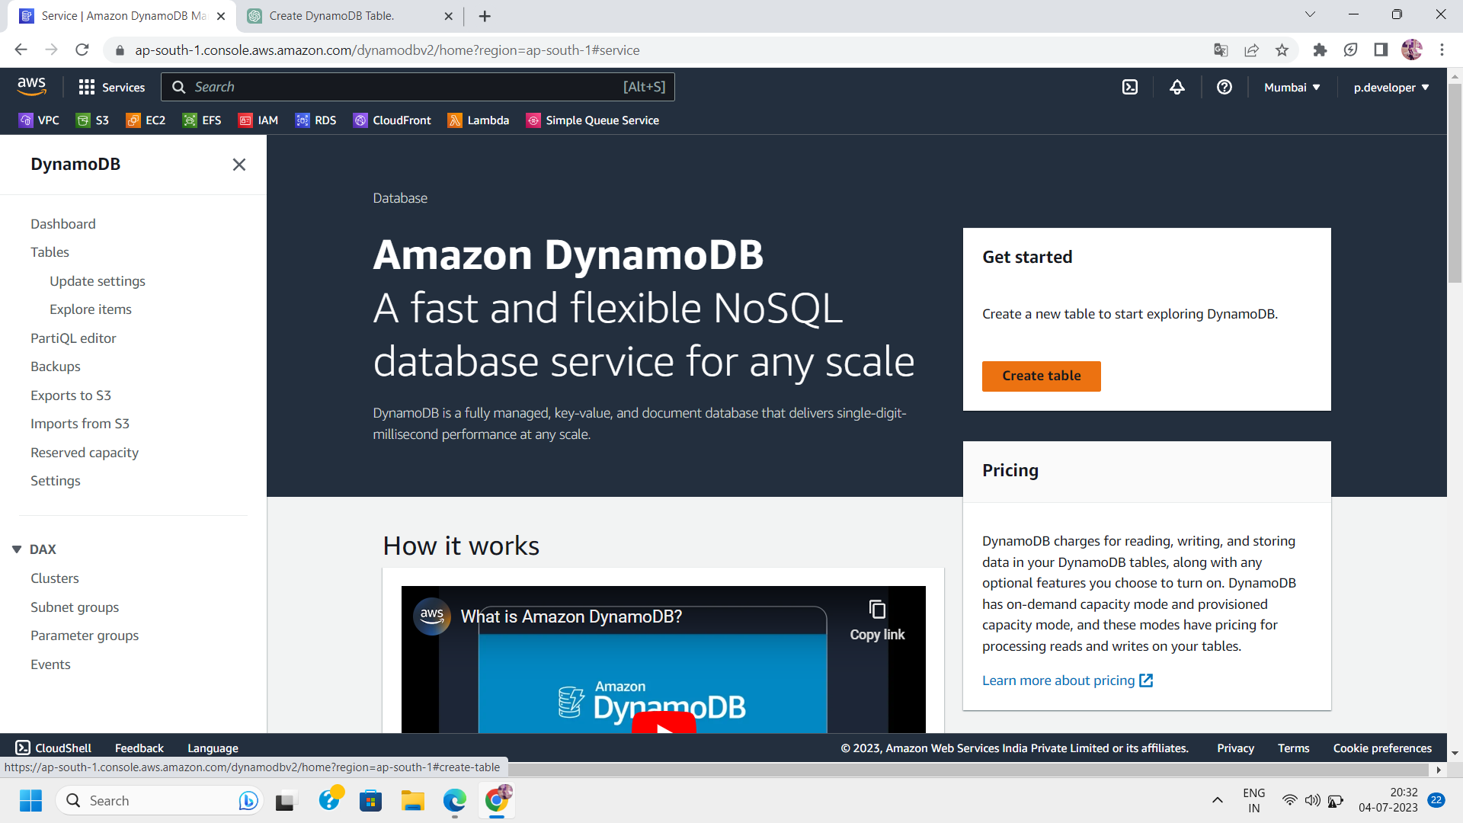

Step 2: Create the dynamoDB table for which you want to maintain LSI.

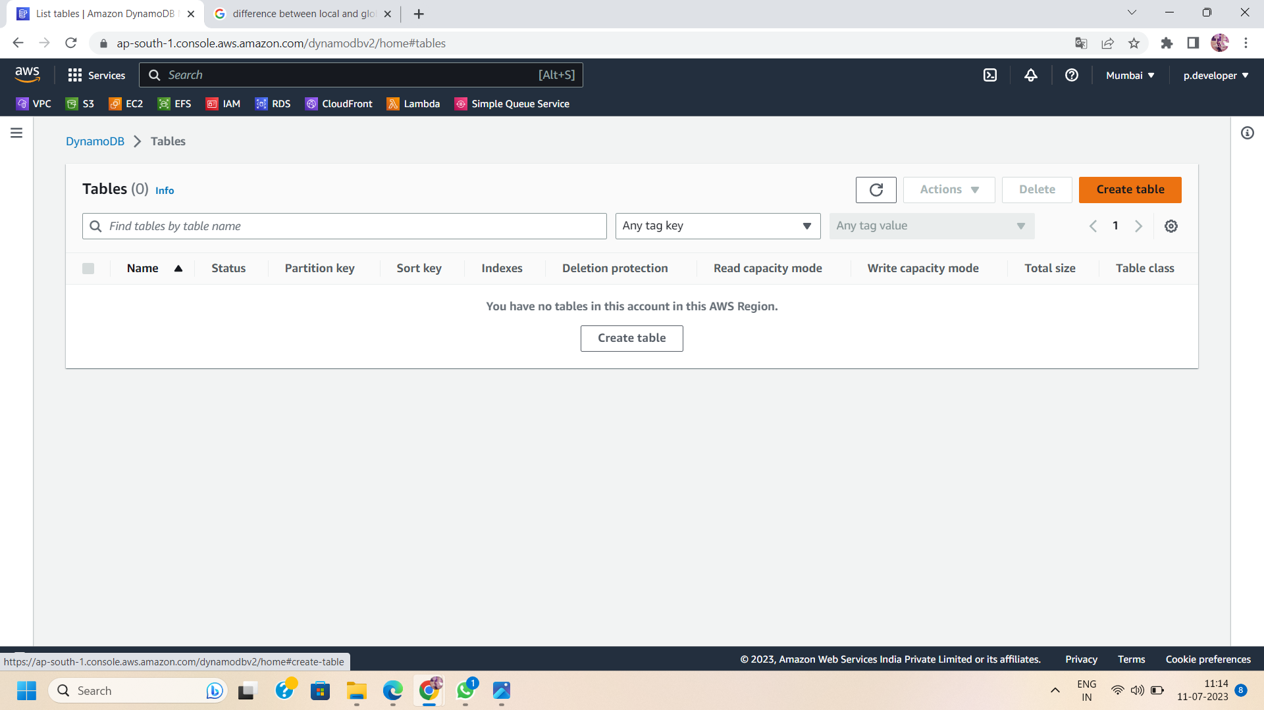

NOTE: Local Secondary Index(LSI) can only be created at the time of creation of table.we cannot create LSI after creating the table.

Step3:In the create table section, give the name of the table,its partition key and sort key.

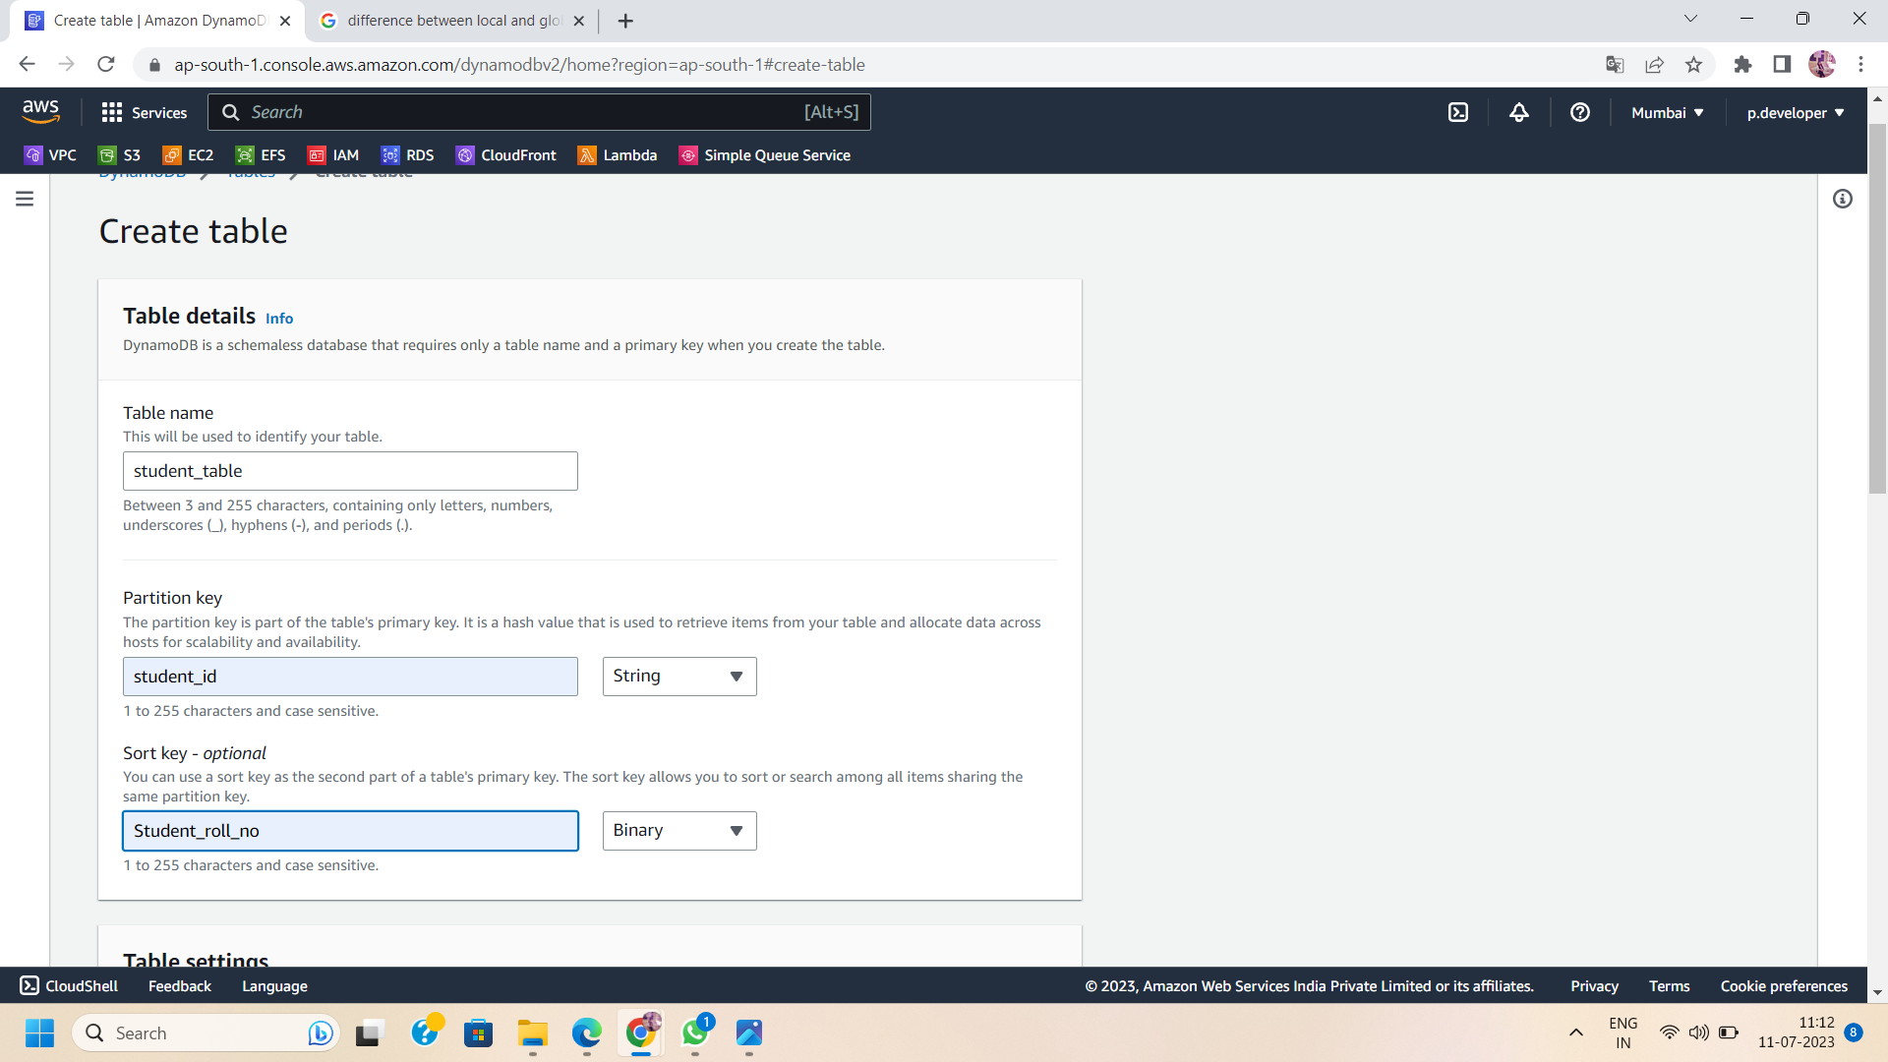

Step4 : On scrolling down in the Create Table section,you will get a section of SEcondary indexes.Click on “Create Local Index '' .

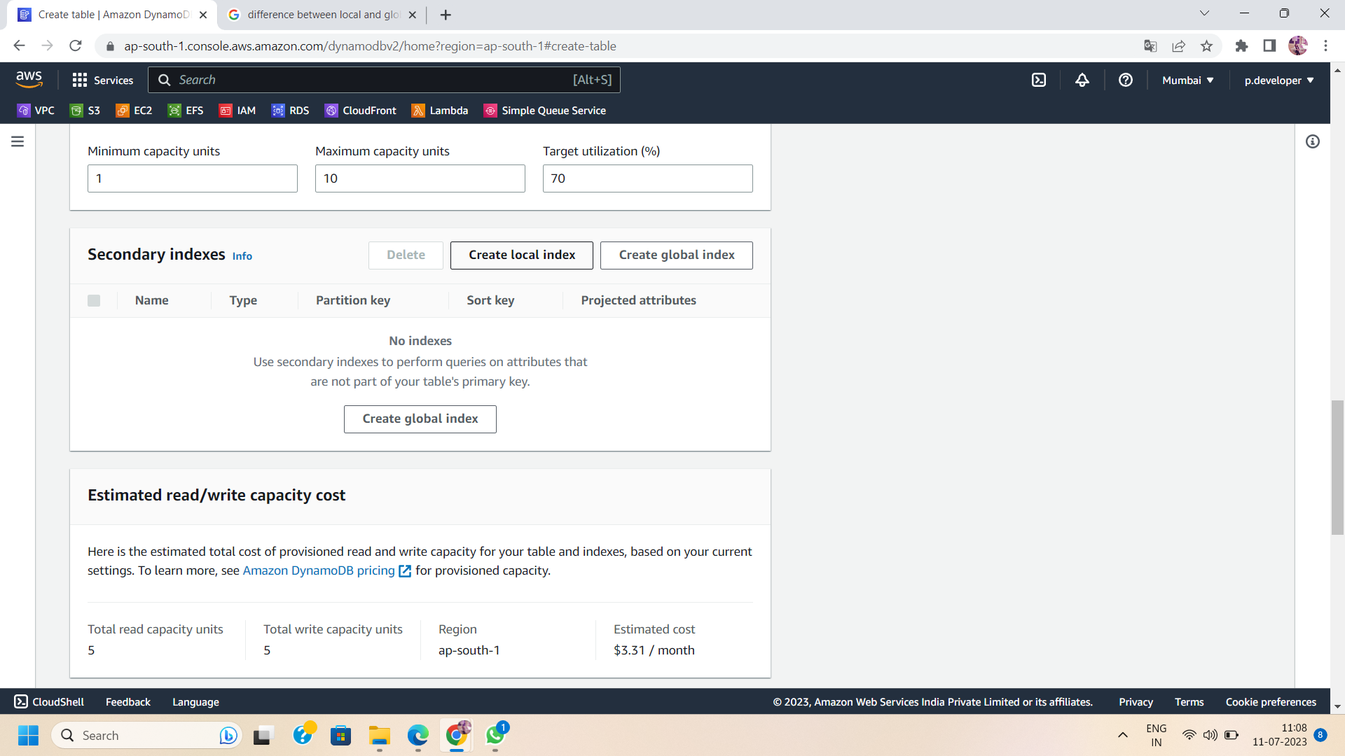

Step 5:After selecting the "Create Local Index" button and providing the necessary details for your LSI. Specify the index name, partition key, and optionally a sort key. Design your LSI to align with your query patterns and access requirements.

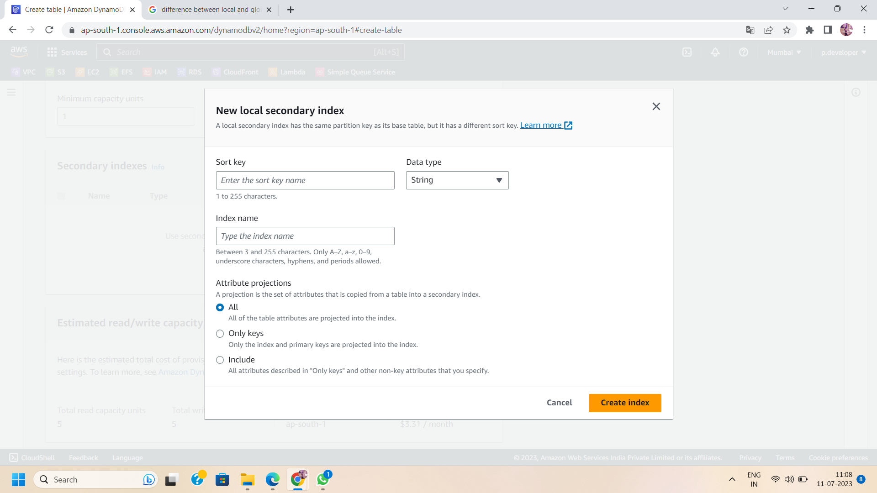

Step 6: After Creating the LSI ,create the dynamoDB table.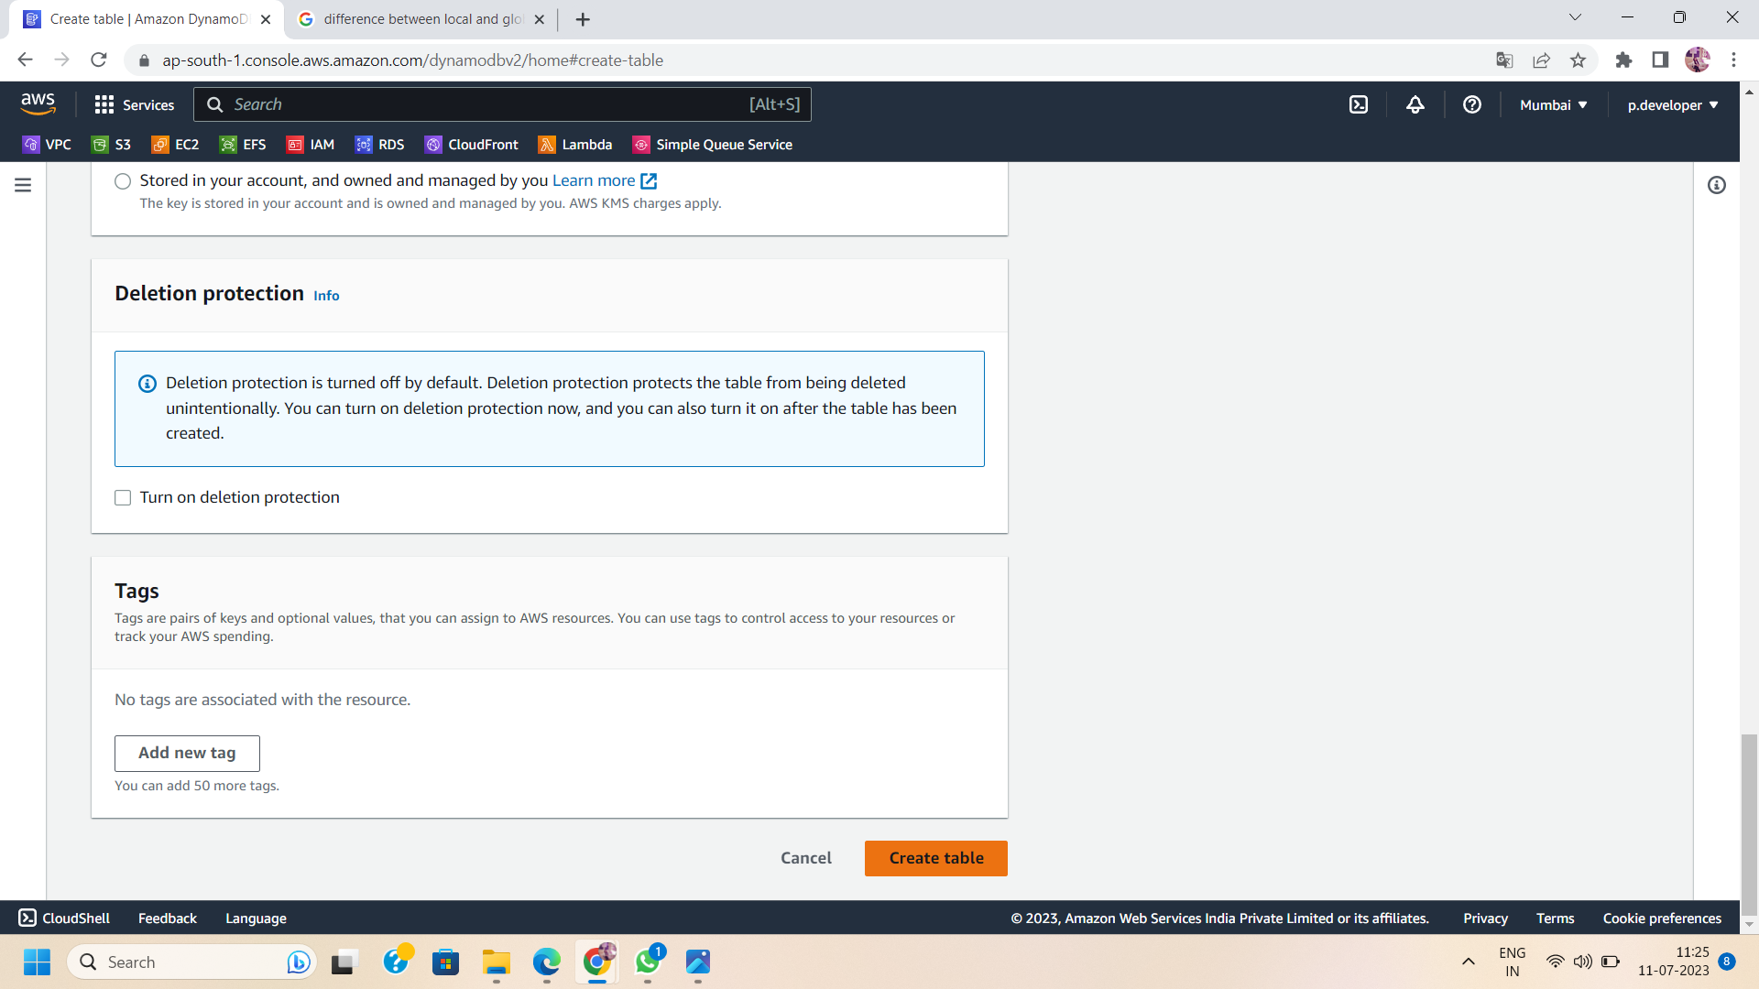

Step 7: creating the LSI, monitor its status and test its query performance. Verify that the LSI is correctly indexed and provides the expected results for your queries.

**Part 2: Global Secondary Indexes (GSIs)**

Step 1: Log in to the AWS Management Console and navigate to the DynamoDB service.



Step 2: Choose the table for which you want to configure a GSI. Ensure that the table structure allows for creating GSIs.

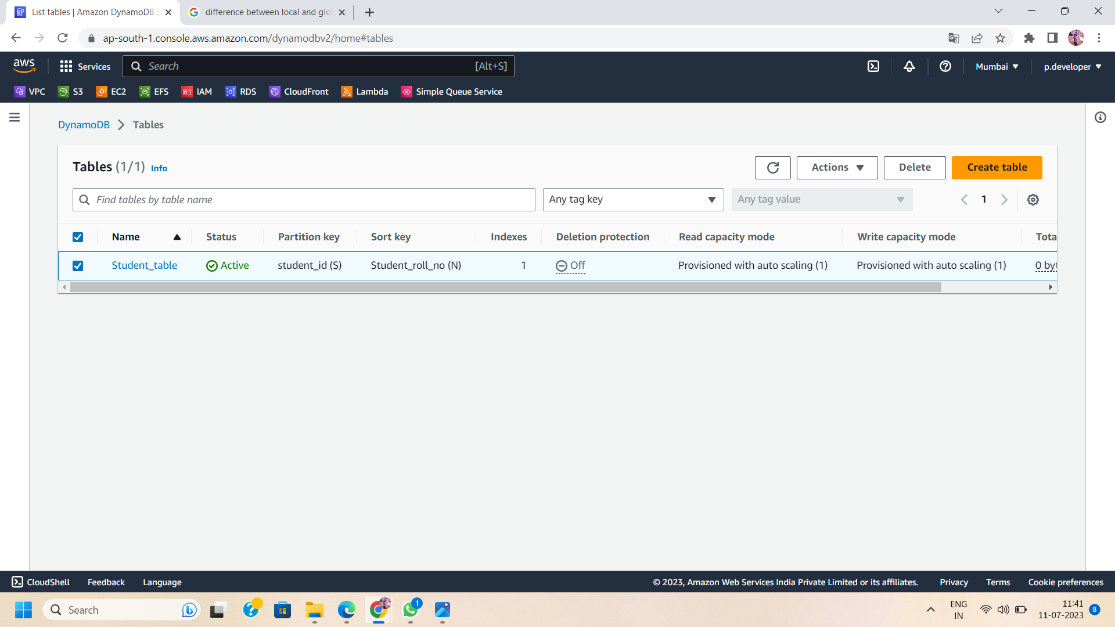

Step 3: Open the Table Overview In the table overview, locate and click on the "Indexes" tab.

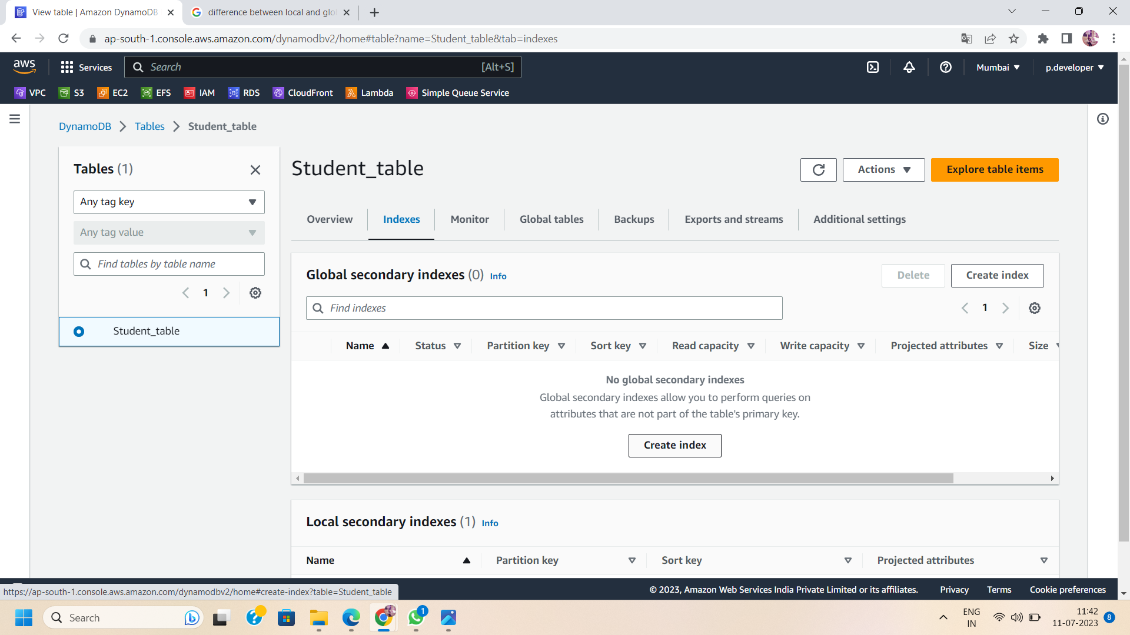

Step 4:Click on the "Create Index" button and provide the necessary details for your GSI. Specify the index name, partition key, and optionally a sort key. Design your GSI to cater to specific query patterns and access requirements.

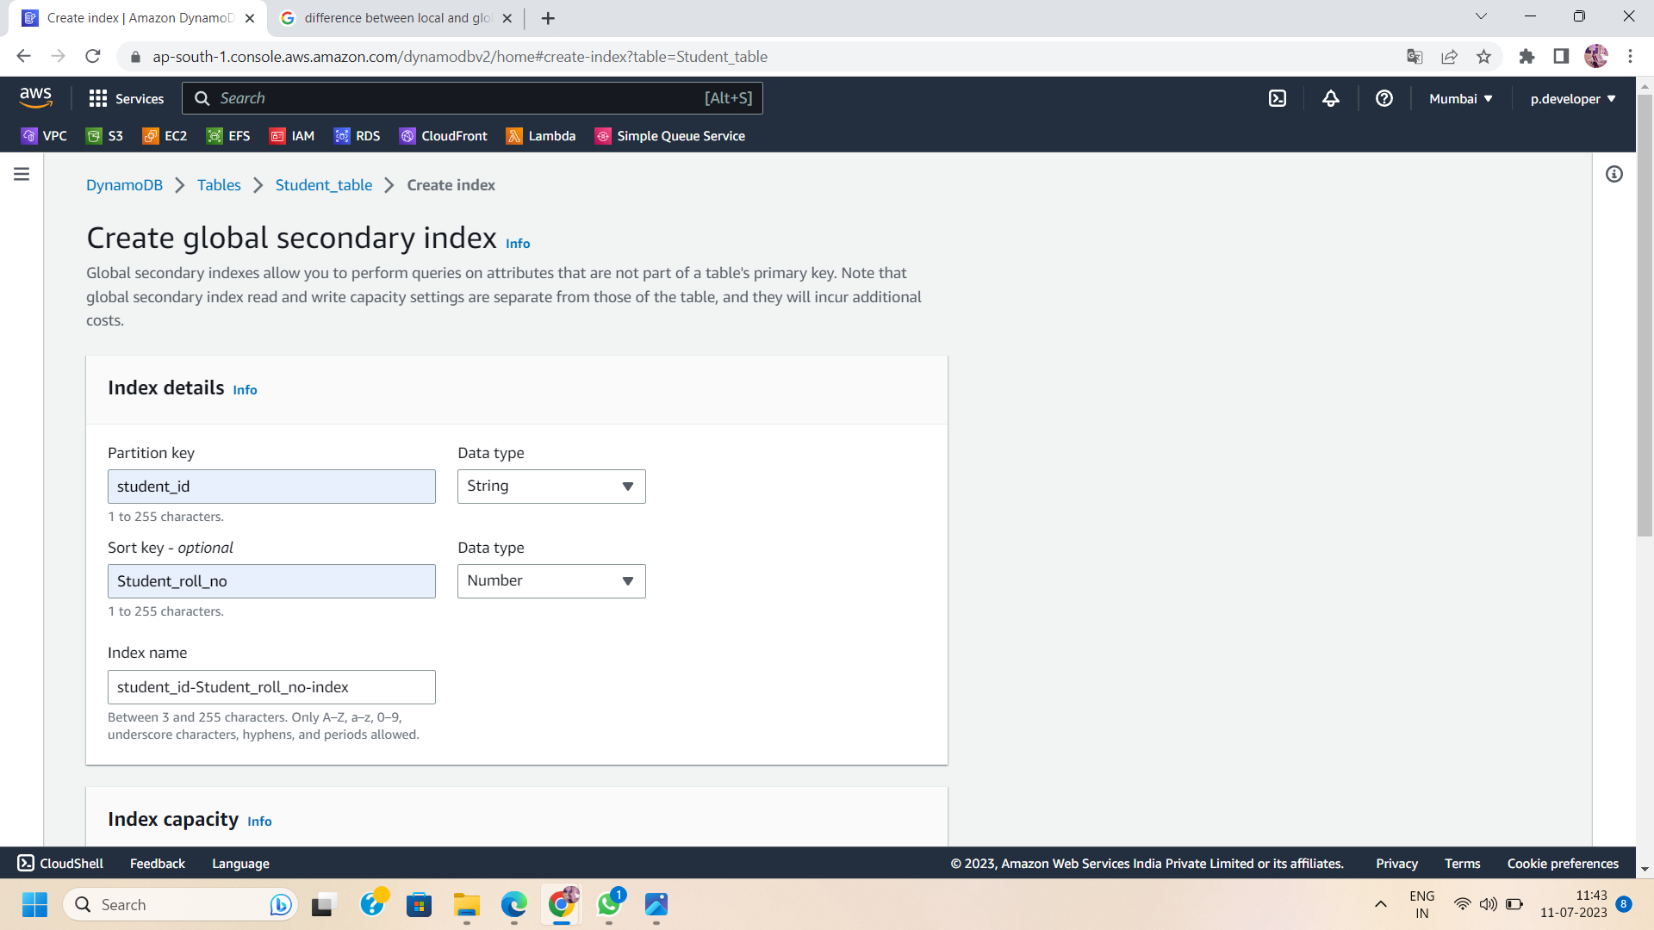

Step 5:Set the desired read and write capacities for the GSI. These capacities are separate from the main table's capacities and can be adjusted based on the query workload.

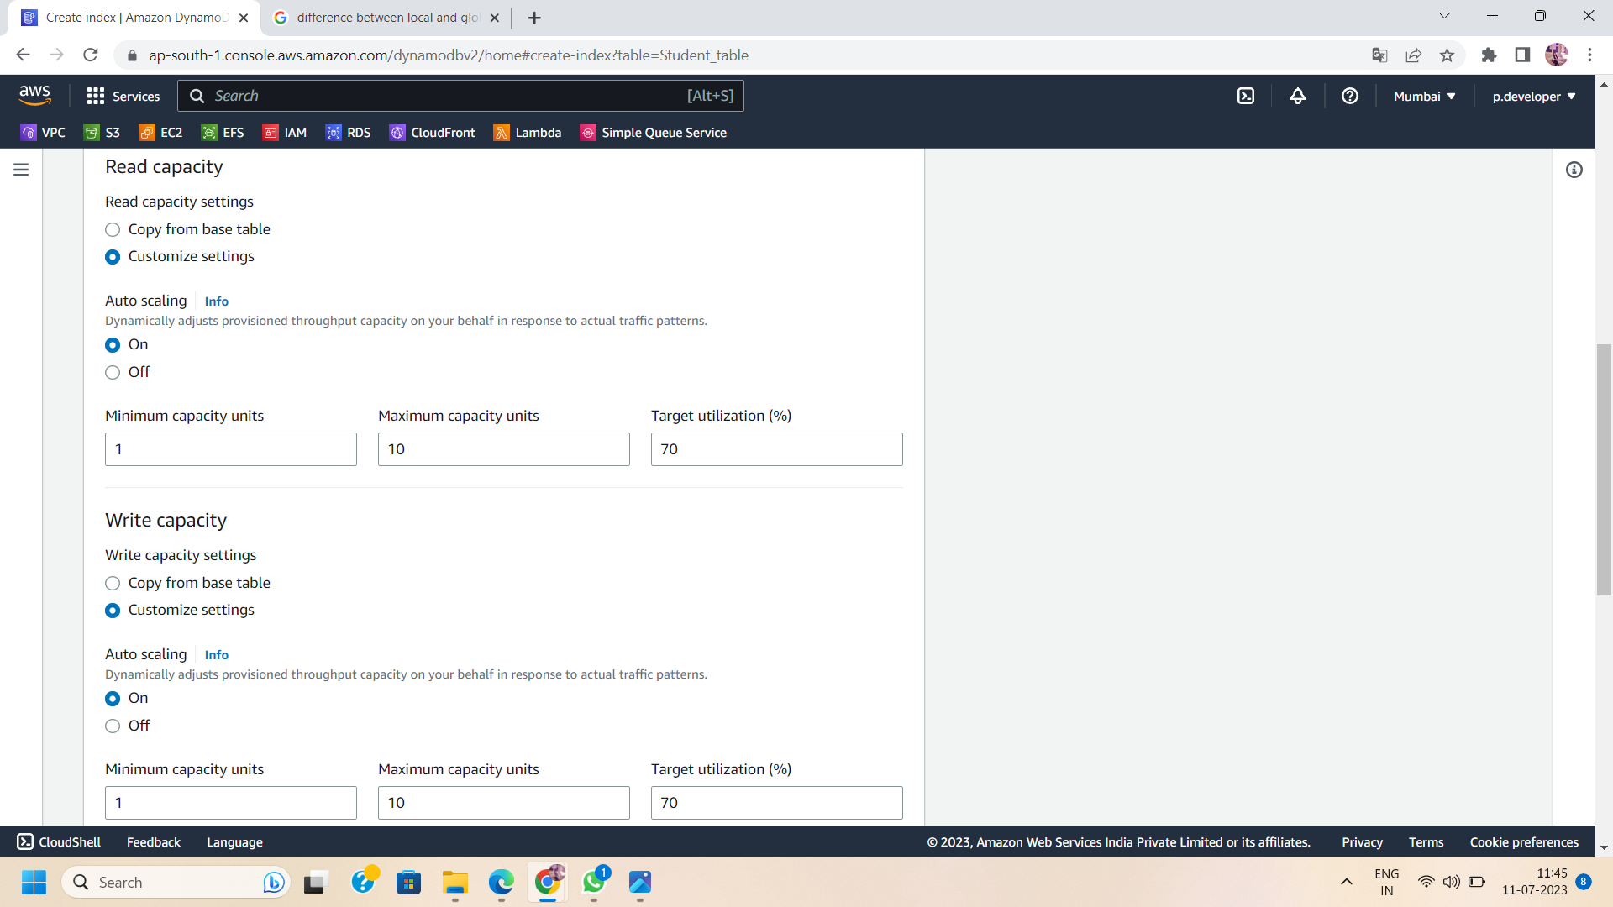

Step 6: Click on “Create Index” to save the GSI settings.

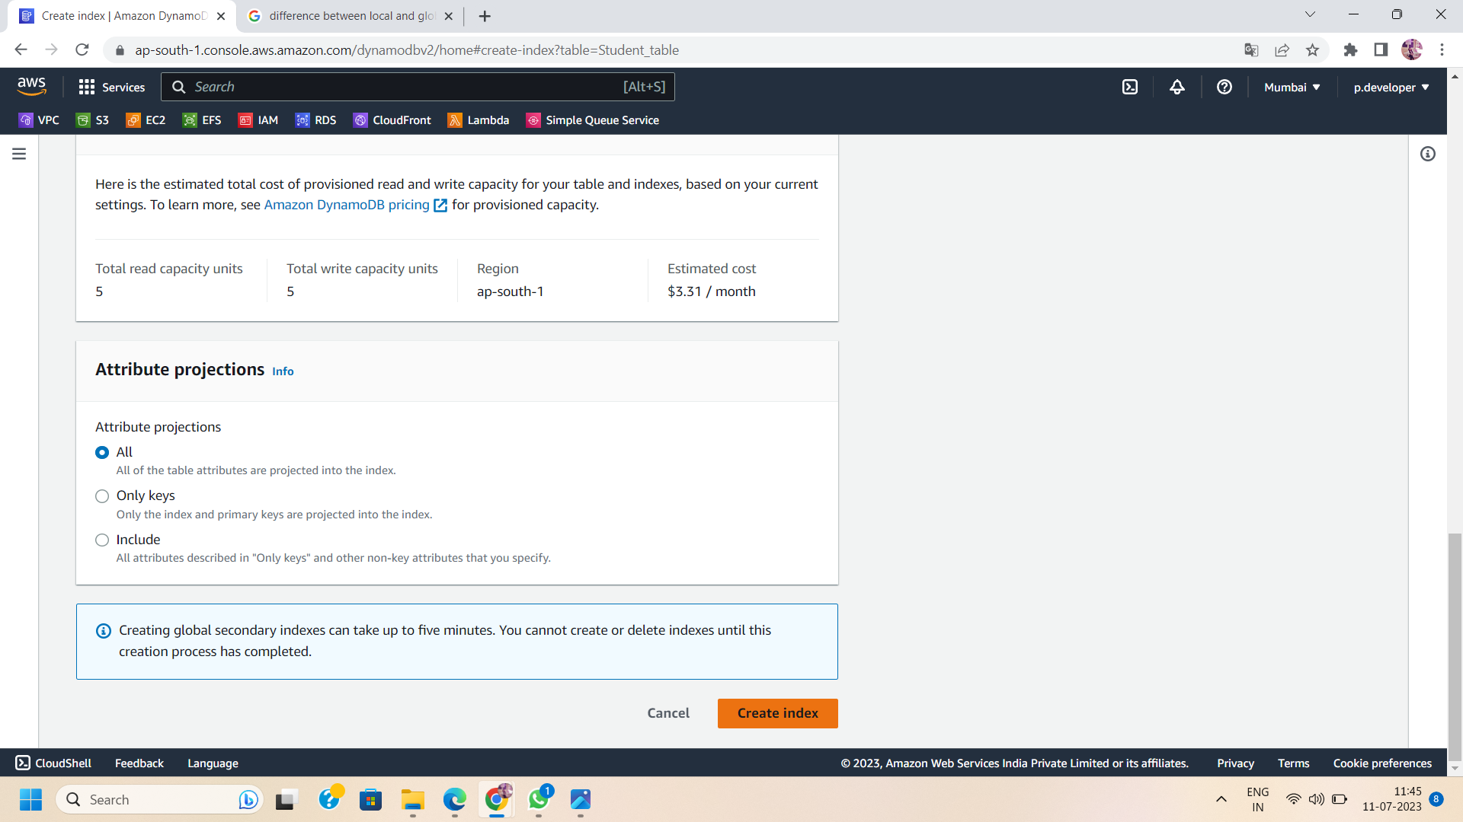

Step 7:After creating the GSI, monitor its status and test its query performance. Verify that the GSI is correctly indexed and provides the expected results for your queries.

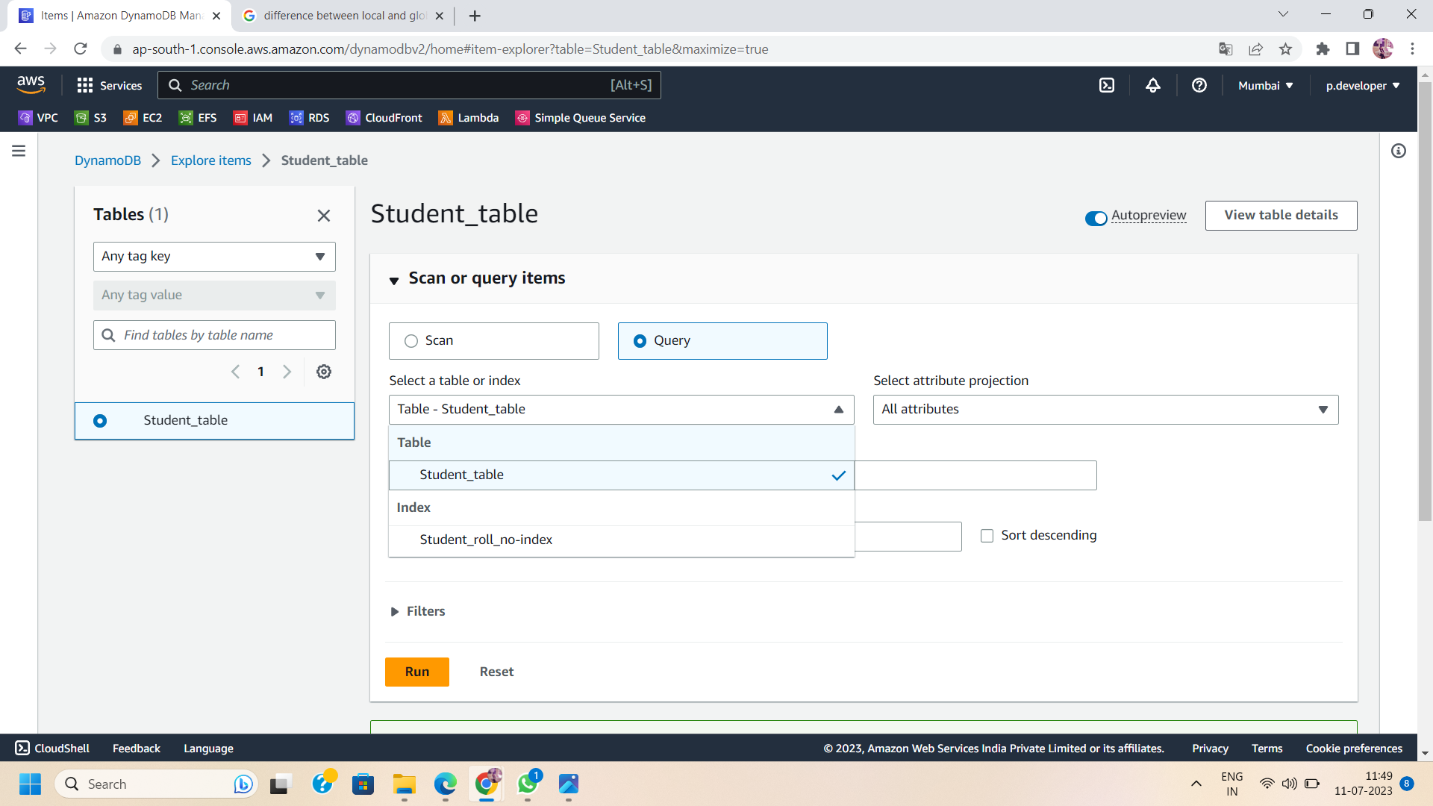

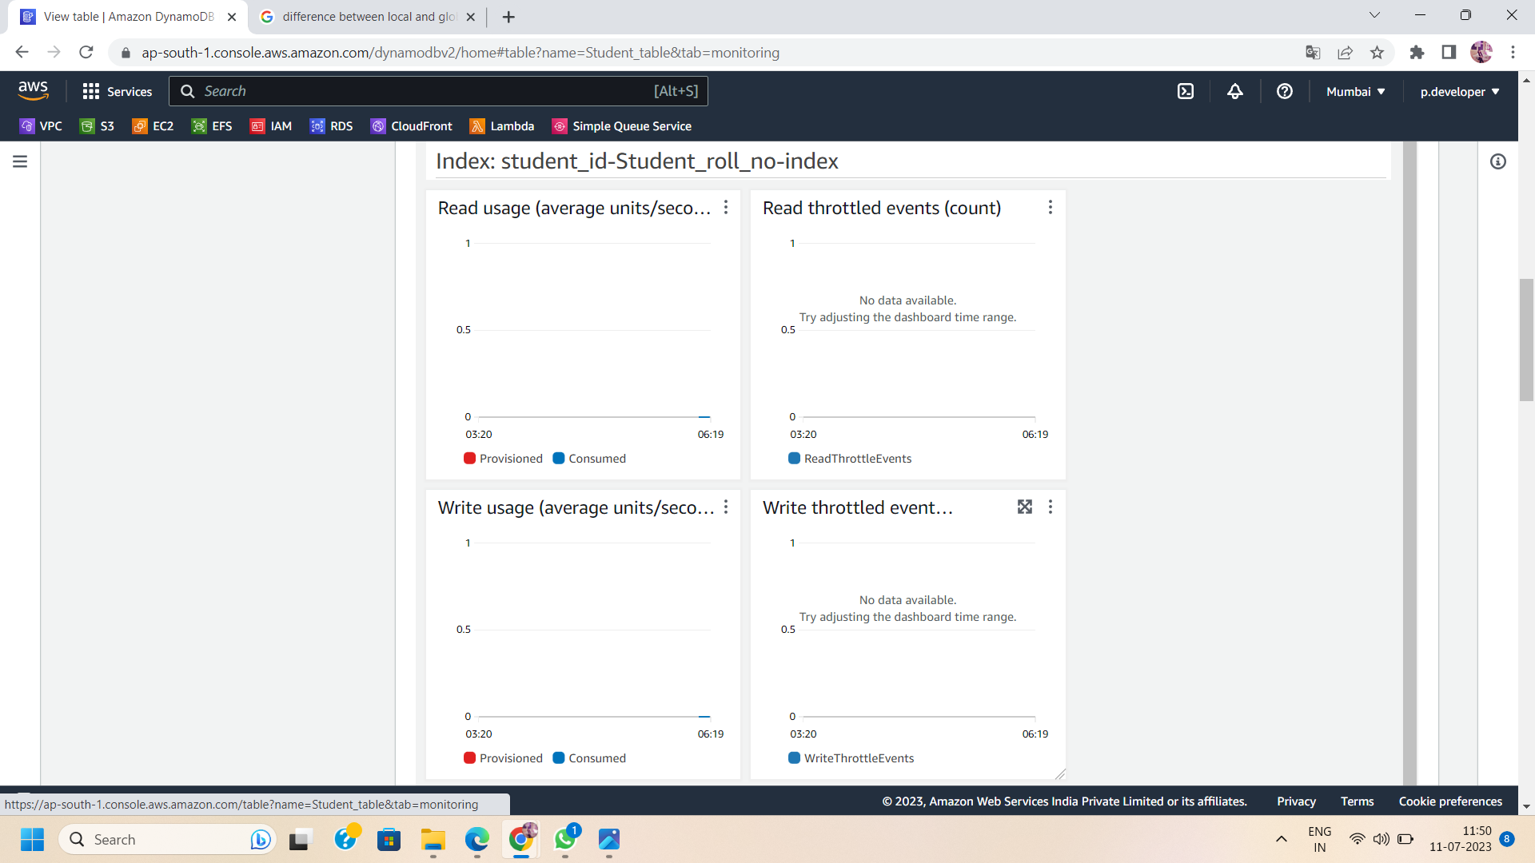

Conclusion:

Configuring Local Secondary Indexes (LSIs) and Global Secondary Indexes (GSIs) in AWS DynamoDB enhances the querying capabilities and allows for more efficient data retrieval. By following the steps outlined in this blog post, you can create LSIs and GSIs that align with your query patterns and access requirements. Leverage the power of indexing to optimize your data access, improve query performance, and unlock the full potential of AWS DynamoDB. Fine-tune and monitor the performance of your LSIs and GSIs to ensure efficient data retrieval and an exceptional user experience. Expand your query capabilities with LSIs and GSIs in DynamoDB and take your application's performance to new heights!